SCHOOL OF COMPUTING
UNIVERSITY OF TEESSIDE
MIDDLESBROUGH
TS1 3BA

Multimodal Interfaces for Games (COM2061)

ICA Component 2
Graphical User Interface for a Games Tool

Aziz Arar
s6053935

04/01/2018

Table of Contents

1 Introduction 3
2 Software Design 4
3 Results 5
4 Conclusion 6
5 REFERENCES/BIBLIOGRAPHY 7

Introduction
The Game Editor I have created is based on my Games Engine Construction Game Demo called HAPIvania. Using the Game Editor, you can place down tiles for the platforming which can be easily saved and loaded in the game and played straight away. The game engine will automatically detect which tiles should have collision.

You can choose the width and height of the level and load in the Tile set XML I had created to load in the Tiles. You can Save and Load levels back into this to continue working on them in the future.

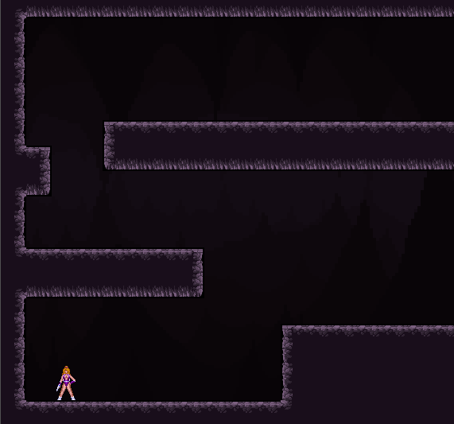

Software Design
The features of the Game Editor include the ability to create, save and load a tile-based level for my Games Engine Construction Demo.

When the level editor opens, pressing create level gives you the ability to choose the size of the level by width and height in terms of tiles. There is an indication of the size underneath in pixels, which will be passed onto the editor window which is the main part of the application.

You can import a Tile set through an XML I had created as the images of the tiles is included in the data of the application and would appear on the left side of the application.
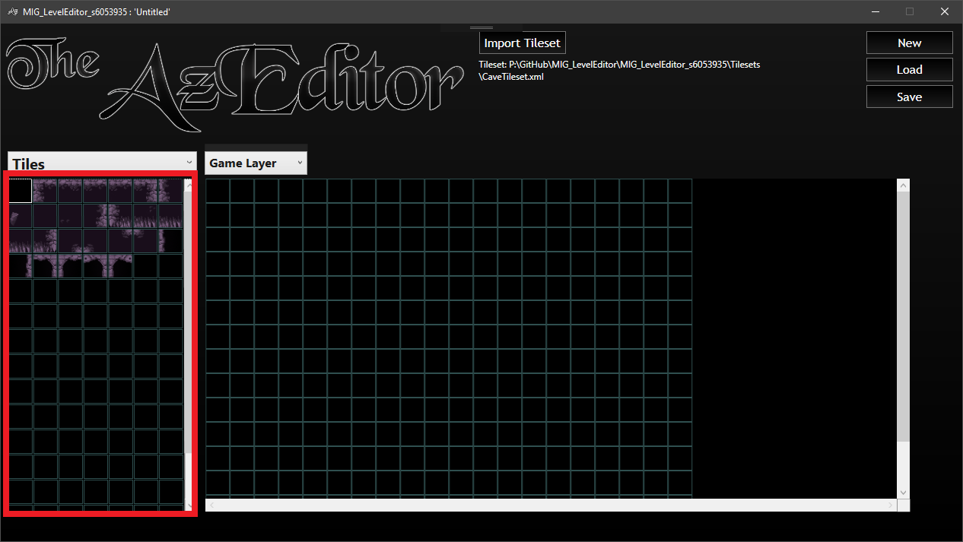
(Outlined in red above)

Once you have selected a tile from the left side, you can draw in the middle by clicking on a tile that you’d like to draw over. You can also click and drag which allows you to draw over multiple tiles at once. If you right, click a tile from the canvas you can copy it so you won’t have to go find it in the tile list.

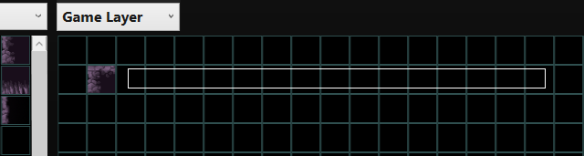
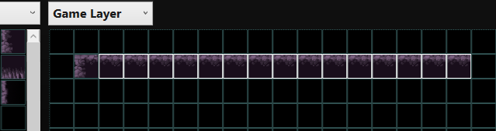
The look of my Game Editor looks like the mock-up design I had created, but the most noticeable change is that the Tiles have moved to the other side.
However, in the dropdown, the only option available is Tiles, unlike my plans to have Objects and Settings.

Results
Loading in Tile sets through XML
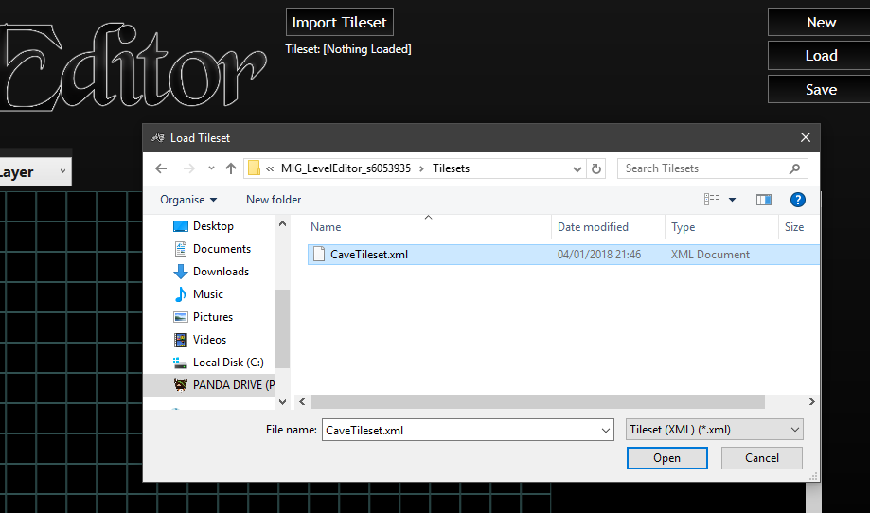
The Tile Editor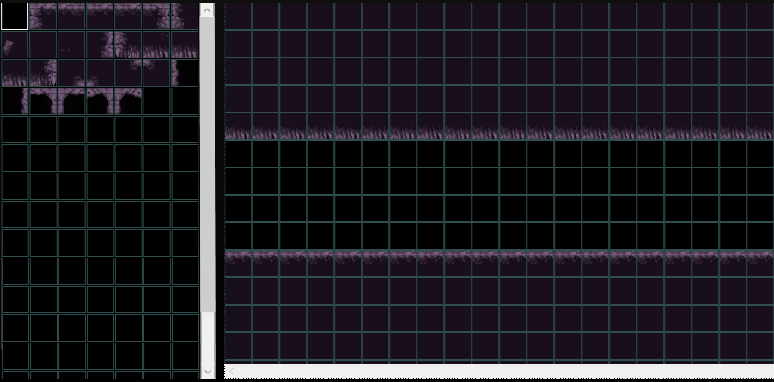

Loading in Levels
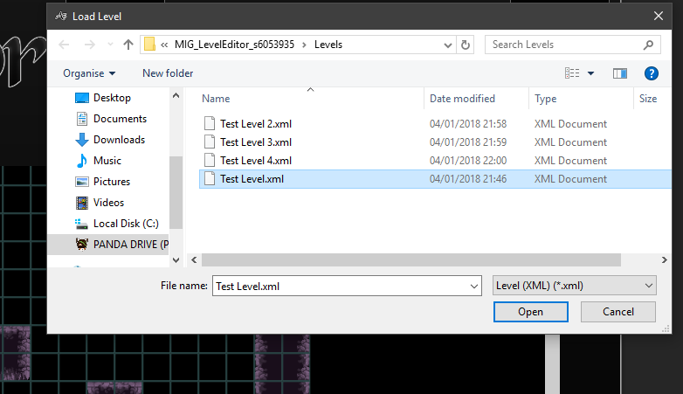

Saving Levels
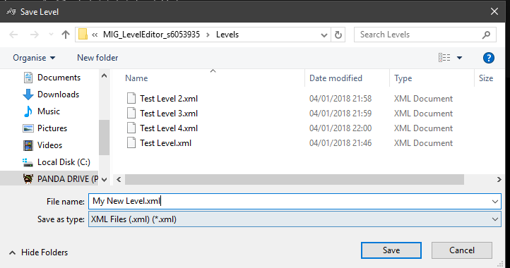

Conclusion
The game editor has taught me a lot about creating a Windows Application as it was my first experience with this and using WPF. This learning experience has given me insight into what kind of features a game editor requires to assist a game in its creation.

I feel that I haven’t achieved what I fully wanted out of this application because I had to cut most of my plans due to time constraints and other problems. I originally intended to have not only tiles, but also a Game Objects and Settings tab which I didn’t get to do.

The dropdown with the default selected Game Layer was an idea that I could have multiple layers of my level such as the Background and Foreground, which would have made the application more in-depth and feel more like a full game editor rather than feature-lacking application I ended up with.

REFERENCES/BIBLIOGRAPHY
Tiles Used: https://opengameart.org/content/cavern-tile-set

